Contents

LAB REPORT 1 2

LAB REPORT 2: 5

LAB REPORT 3 10

LAB REPORT 4 14

LAB REPORT 5 20

LAB REPORT 6 26

LAB REPORT 7 30

LAB REPORT 8 33



# **LAB REPORT 1**

**Ohm’s law**

**Date of Experiment:**

**Date of Report:**

**Members:**



**Ohm’s Law**

|  |  |  |  |  |  |  |
| --- | --- | --- | --- | --- | --- | --- |
| No | Resistance, ohm | | Current, amp | Voltage, volt | Voltage/ Resistance | %Error |
| Average value of R | The tolerance limit of R |
| 1 |  |  |  |  |  |  |
| 2 |  |  |  |  |  |  |
| 3 |  |  |  |  |  |  |
| 4 |  |  |  |  |  |  |
| 5 |  |  |  |  |  |  |

1. Construct a graph of Current (vertical axis) vs. Resistance

1. From your graph, what is the mathematical relationship between Current and Resistance?

1. Ohm’s Law states that current is given by the ratio of voltage/resistance. Does your data  
   concur with this? Use your data to prove your conclusion

1. What were possible sources of experimental error in this lab? Would you expect each to  
   make your results larger or to make them smaller?



# **LAB REPORT 2:**

**Resistances in Circuits**

**Date of Experiment:**

**Date of Report:**

**Members:**

6. **SAME RESISTORS**

**Experimental data:**

|  |  |  |  |  |  |
| --- | --- | --- | --- | --- | --- |
|  | **Colors**  **1st  2nd 3rd 4th** | **Coded Resistance** | **Measured Resistance** | **% Error** | **Tolerance** |
| #1 |  |  |  |  |  |
| #2 |  |  |  |  |  |
| #3 |  |  |  |  |  |

|  |  |
| --- | --- |
| **Circuits** | **Resistances** |
| **Series**  a | R­12= ____________  R­23= ____________  R­123= ___________  Req(calculated) = |
| **Parallel**  b | R­12= ____________  R­23= ____________  R­123= ___________  Req(calculated) = |
| **Combination**  c | R­1= ____________  R­23= ____________  R­123= ____________  Req(calculated) = |

**Questions:**

1. How is a multimeter inserted in a circuit in order to measure current, voltage and resistance?

1. How does the % error compare to the coded tolerance for your resistors?

1. What is the apparent rule for combining **equal resistances** in series circuits? In parallel circuits? In combination circuits? Cite evidence from your data to support your conclusions.

1. **DIFFERENT RESISTORS**

|  |  |  |  |  |  |
| --- | --- | --- | --- | --- | --- |
|  | **Colors**  **1st  2nd 3rd 4th** | **Coded Resistance** | **Measured Resistance** | **% Error** | **Tolerance** |
| #1 |  |  |  |  |  |
| #2 |  |  |  |  |  |
| #3 |  |  |  |  |  |

|  |  |
| --- | --- |
| **Circuits** | **Resistances** |
| **Series**  a | R­12= ____________  R­23= ____________  R­123= ___________  Req(calculated) = |
| **Parallel**  b | R­12= ____________  R­23= ____________  R­123= ___________  Req(calculated) = |
| **Combination**  c | R­1= ____________  R­23= ____________  R­123= ____________  Req(calculated) = |

1. What is the apparent rule for combining **unequal resistances** in series circuits? In parallel circuits? In combination circuits? Cite evidence from your data to support your conclusions.

1. Is your measured value of Req similar to your calculated value? Explain



# **LAB REPORT 3**

**LRC CIRCUITS**

**Date of Experiment:**

**Date of Report:**

**Members:**

6. **LC Oscillations**

**Theoretical values:**

Inductance:

Capacitance:

Angular frequency (theory):

**Experimental data:**

Time at max/min current:

Time at next max/min current:

Time difference:

Period:

Linear frequency:

Angular frequency (experiment):

Compare the angular frequencies between theory and experiment:

1. **Resistive Circuit**

Resistance:

Period of the AC voltage:

Time at max/min current:

Time at max/min voltage:

Time difference:

Phase difference:

Compare the phase difference with the value predicted by theory:

1. **Capacitive Circuit**

Capacitance:

Period of the AC voltage:

Time at max/min current:

Time at max/min voltage:

Time difference:

Phase difference:

Compare the phase difference with the value predicted by theory:

1. **Inductive Circuit**

Inductance:

Period of the AC voltage:

Time at max/min current:

Time at max/min voltage:

Time difference:

Phase difference:

Compare the phase difference with the value predicted by theory:

1. **LRC Circuit**
2. Inductance:

Resistance:

Capacitance:

Frequency at which current reaches its max:

1. Inductance:

Resistance:

Capacitance:

Frequency at which current reaches its max:

Compare the angular frequency in LRC circuit with the one in LC Oscillations. Does the frequency change when the resistance changes?

Does the resistance affect the high of the peak? If yes, show your experimental data and explain.



# **LAB REPORT 4**

**KIRCHHOFF’S LAWS**

**Date of Experiment:**

**Date of Report:**

**Members:**



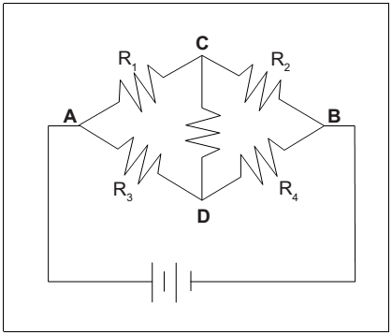

**Experimental Data:**

**Table 4.1**

|  |  |  |  |  |  |
| --- | --- | --- | --- | --- | --- |
| **Resistance (Ω)** | | **Voltage (V)** | | **Current (mA)** | |
| R1 |  | V1 |  | I1 |  |
| R2 |  | V2 |  | I2 |  |
| R3 |  | V3 |  | I3 |  |
| R4 |  | V4 |  | I4 |  |
| R5 |  | V5 |  | I5 |  |
| RTotal |  | VTotal |  | ITotal |  |

Using the schematic of the circuit, calculate the total resistance of the circuit. Record the value in the Table. 4.1. Based on the calculated resistance and the voltage across A and B, calculate the theoretical value of the current using Ohm’s Law.

Total current (theoretical) = __________ (A)

Calculate the percent difference between the theoretical current and the measured current:



Write down the Kirchhoff’s current law at the junctions A, B, C, and D into the table below. Use the experimental data above to find the net current flowing into (or out of) the junctions.

|  |  |  |  |  |  |
| --- | --- | --- | --- | --- | --- |
| **Junction** | **Kirchhoff’s current law** | **Current (mA, calculation)** | | **Current (mA, measure)** | |
| A |  | ITotal |  | ITotal |  |
| B |  | ITotal |  | ITotal |  |
| C |  | I1 |  | I1 |  |
| D |  | I3 |  | I3 |  |

Compare the currents calculated from Kirchhoff’s current law and those measured from experiment. Does the Kirchhoff’s current law hold true in the experiment?

Write down the Kirchhoff’s voltage law for 4 different loops. For each loop, use the experimental data above to find the potential difference between a chosen component.

|  |  |  |  |  |  |
| --- | --- | --- | --- | --- | --- |
| **Loop** | **Kirchhoff’s voltage law** | **Voltage (V, calculation)** | | **Voltage (V, measure)** | |
| VR1R5R4 |  | V1 |  | V1 |  |
| VR3R5R2 |  | V3 |  | V3 |  |
| VR1R2 |  | V1 |  | V1 |  |
| VR3R4 |  | V2 |  | V2 |  |

Compare the voltages calculated and those measured from experiment. Does the Kirchhoff’s voltage law hold true in the experiment?

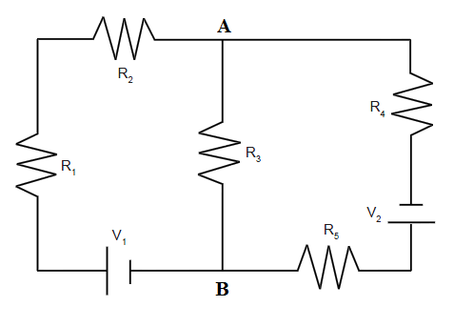

**Experimental Data:**

|  |  |  |  |  |  |
| --- | --- | --- | --- | --- | --- |
| **Resistance (Ω)** | | **Voltage (V)** | | **Current (mA)** | |
| R1 |  | V1 |  | I1 |  |
| R2 |  | V2 |  | I2 |  |
| R3 |  | V3 |  | I3 |  |
| R4 |  | V4 |  | I4 |  |
| R5 |  | V5 |  | I5 |  |
|  |  | V01 |  | I01 |  |
|  |  | V02 |  | I02 |  |

Write down the Kirchhoff’s current law at the junctions A and B into the table below. Use the experimental data above to find the net current flowing into (or out of) the junctions.

|  |  |  |  |  |  |
| --- | --- | --- | --- | --- | --- |
| **Junction** | **Kirchhoff’s current law** | **Current (mA, calculation)** | | **Current (mA, measure)** | |
| A |  | I2 |  | I2 |  |
| B |  | I5 |  | I5 |  |

Compare the currents calculated from Kirchhoff’s current law and those measured from experiment. Does the Kirchhoff’s current law hold true in the experiment?

Write down the Kirchhoff’s voltage law for 3 different loops. For each loop, use the experimental data above to find the potential difference between a chosen component.

|  |  |  |  |  |  |
| --- | --- | --- | --- | --- | --- |
| **Loop** | **Kirchhoff’s voltage law** | **Voltage (V, calculation)** | | **Voltage (V, measure)** | |
| V1R1R2R3 |  | V1 |  | V1 |  |
| V2R5R3R4 |  | V3 |  | V3 |  |
| V1R1R2R4V2R5 |  | V4 |  | V4 |  |

Compare the voltages calculated and those measured from experiment. Does the Kirchhoff’s voltage law hold true in the experiment?



# **LAB REPORT 5**

**RC CIRCUIT**

**Date of Experiment:**

**Date of Report:**

**Members:**



**PROCEDURE A:**

**Charging the Capacitor**

|  |  |  |  |  |  |  |  |  |
| --- | --- | --- | --- | --- | --- | --- | --- | --- |
|  | **Theoretical** | | | **Experimental Determinations of the Time Constant** | | | | |
|  | 1 | 2 | | 3 | |
|  |  |  |  | (time to 63% Vmax) | (time to 50% Vmax) |  |  |  |
| **Case 1** | 1000Ω | 330µF | **0.33s** | 0.315 | **0.22** | **0.31** | **2.9** | **0.322** |
|  |  |  | % errors: | **4.5%** |  | **2.21%** |  | **2.42%** |
|  |  |  |  |  |  |  |  |  |
| **Case 2** | **3300Ω** | **330µF** | 1.09s | **1.065** | **0.74s** | **1.06s** | **9.6s** | **1,066s** |
|  |  |  | % errors: | **2.3%** |  | **3.956%** |  | **2,2%** |
|  |  |  |  |  |  |  |  |  |
| **Case 3** | **3900Ω** | **330µF** | 1.287s | **1.26s** | **0.875** | **1.262** | **11.5s** | **1.278** |
|  |  |  | % errors: | **2.09%** |  | **2.8%** |  | **0.7%** |

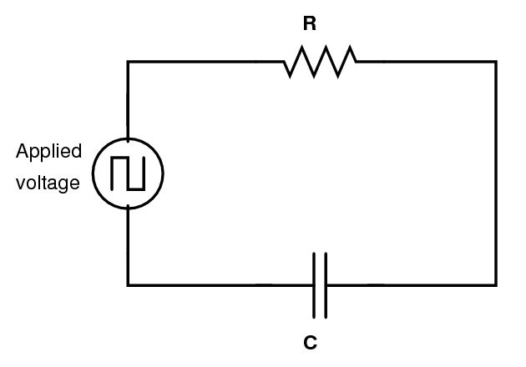**PROCEDURE B:**

**Discharging the Capacitor**

|  |  |  |  |  |  |  |  |  |  |
| --- | --- | --- | --- | --- | --- | --- | --- | --- | --- |
|  | Theoretical | | | Discharging  Process | | | Half Life | Time constant | Time constant |
|  |  |  |  | Started at | 50% max | 37% max |
| **Case 1** | **1000Ω** | **330µF** | **0.33s** | **2.87s** | **3.095** | **3.2** | **0.225s** | 0.325s | **0.33s** |
|  |  |  |  |  |  |  | %  Errors: | **1.51%** | **0%** |
|  | 0.168 | |  |  |  |  |  |  |  |
|  |  |  |  |  |  |  |  |  |  |
| **Case 2** | **3300Ω** | **330µF** |  |  |  |  |  |  |  |
|  |  |  |  |  |  |  | %  Errors: |  |  |
|  |  | |  |  |  |  |  |  |  |
| **Case 3** | **3900Ω** | **330µF** | **1.287s** | **2** |  |  |  |  |  |
|  |  |  |  |  |  |  | %  Errors: |  |  |
|  | 0.0432 | |  |  |  |  |  |  |  |

**QUESTIONS PROCEDURE A:**

**Charging the Capacitor**

1. Compare the time constants () with the changing of resistance R in three cases above.

1. Compare the times to fully charge  with the changing of time constants () in three cases above.

1. Given that, what was the maximum current stored in the capacitor in each case? Show the calculations here:

1. What are some factors that could account for the difference between the theoretical and experimental values? Which experimental value of time constant, if any, has the largest uncertainty? Explain.

**QUESTIONS PROCEDURE B:**

**Discharging the Capacitor**

1. Was the half-life for charging the same as the half-life for discharging?

1. Which circuit discharges faster, the one with higher or the one with lower?



# **LAB REPORT 6**

**LR CIRCUIT**

**Date of Experiment:**

**Date of Report:**

**Members:**



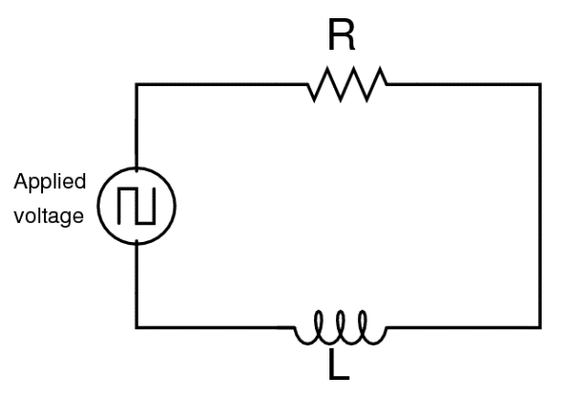

**Experimental data:**

**a.**

|  |  |
| --- | --- |
| **Item** | **Value** |
| Inductor resistance | 9 |
| Resistor resistance | 18 |
| Total resistance | 27 |
| Time at peak voltage | 0.0235 |
| Time at half-maximum voltage | 0.025 |
| Time to reach half-maximum | 0.0015 |
|  | 0.00216 |
|  | 0.0015 |

**b.**

|  |  |
| --- | --- |
| **Item** | **Value** |
| Inductor resistance | 9 |
| Resistor resistance | 10 |
| Total resistance | 19 |
| Time at peak voltage | 0.0242 |
| Time at half-maximum voltage | 0.0254 |
| Time to reach half-maximum | 0.0012 |
|  | 0.00173 |
|  | 0.00147 |

**Questions:**

1. How does the inductive time constant found in this experiment compare to the theoretical value given by ? (Remember that R is the total resistance of the circuit and therefore must include the resistance of the coil as well as the resistance of the resistor.)

The inductive time constant from the measurement (0,00147s) is close to the theoretical value (0,0015s) given by formula from coded value. We consider the experimental error from 2 resistances and total resistance wont heavily effect the experiment.

1. Does Kirchhoff’s Loop Rule hold at all times? Use the graphs to check it for at least three different times. Does the sum of the voltages across the resistor and the inductor equal the source voltage at any given time?

1. How does the value of the resistor effect to the inductive time constant τ?

The bigger Resistor value give the shorter inductive time constant (τ=L/R).

**Extension**

|  |  |
| --- | --- |
| **Item** | **Value** |
| Time at peak voltage | 0.0438 |
| Time at half-maximum voltage | 0.05 |
| Time to reach half-maximum | 0.0062 |
|  | 0.009 |

From the table above, calculate the new value of inductance. How does the iron core affect to the value of the inductance?

The iron core cause the magnetic field to flow more in the core and increase the inductance value**.**.



# **LAB REPORT 7**

**MAGNETIC FIELDS OF COILS**

**Date of Experiment:**

**Date of Report:**

**Members:**

6. What is the purpose of the experiment?

1. Briefly describe the experiment in your own words?

1. **Magnetic fields of a single coil** (attach the graph describing the magnetic field strength along the axis perpendicular to the coil plane and through the center of the coil in the report): Base on your graph, does the theoretical line fit the experimental data everywhere? Explain.

1. **Magnetic fields of two coils** (attach the graph describing the magnetic field strength along the axis perpendicular to the coil planes and through the center of the coils in a case  in the report): Base on your graph, do the theoretical lines fit the experimental data everywhere? Explain.

1. **Magnetic fields of a solenoid** (attach the graph describing the magnetic field strength as a function of location in the report): Calculate the magnetic field strength inside the solenoid. Compare with the value found from your experimental data.



# **LAB REPORT 8**

**THE e/m EXPERIMENT**

**Date of Experiment:**

**Date of Report:**

**Members:**

6. What is the purpose of the experiment?

1. Describe briefly in your own words how the electron’s charge to mass ratio is determined.

1. Base on your experimental results, how does the radius of electron’s path change when
   1. the accelerating potential increase/decrease while fixing the current in the Helmholtz coils? Explain.

|  |  |  |  |
| --- | --- | --- | --- |
|  | Accelerating potential | Current in the Helmholtz coils | Radius of electron’s path |
| 1 |  | 0.9 A |  |
| 2 |  | 0.9 A |  |
| 3 |  | 0.9 A |  |
| 4 |  | 0.9 A |  |
| 5 |  | 0.9 A |  |

* 1. the current in the Helmholtz coils increase/decrease? Explain.

|  |  |  |  |
| --- | --- | --- | --- |
|  | Accelerating potential | Current in the Helmholtz coils | Radius of electron’s path |
| 1 | 95 V |  |  |
| 2 | 95 V |  |  |
| 3 | 95 V |  |  |
| 4 | 95 V |  |  |
| 5 | 95 V |  |  |

1. Base on your experimental data, calculate the average e/m ratio.

1. Compare your average e/m ratio with the standard value? Explain factors in the experiment that can affect the result.